<https://kubernetes.io/docs/setup/production-environment/tools/kubeadm/create-cluster-kubeadm/>

<https://tse-hyd.s3.amazonaws.com/kubernetes+Notes/kubernetes+Notes+Day2.rar>

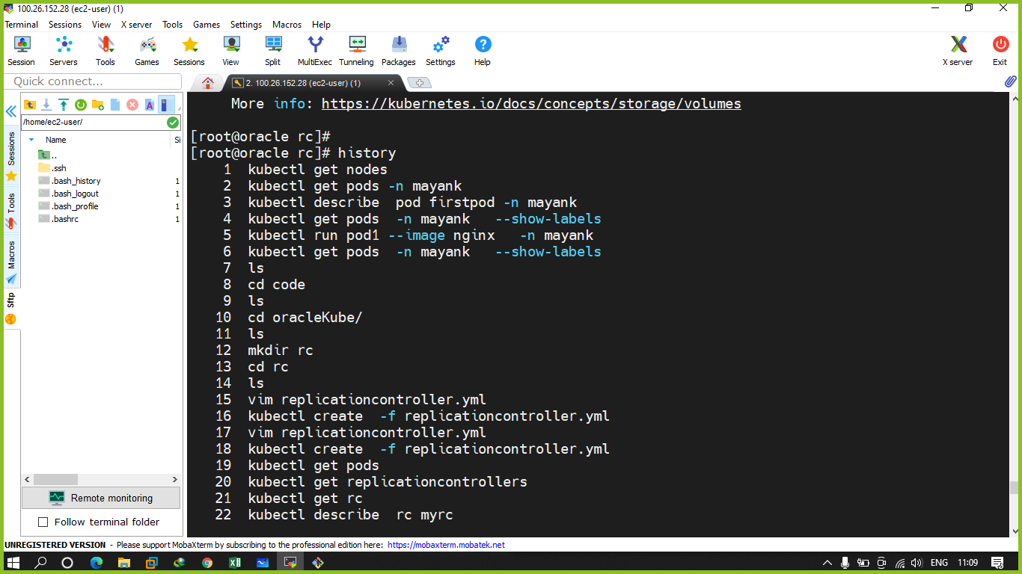

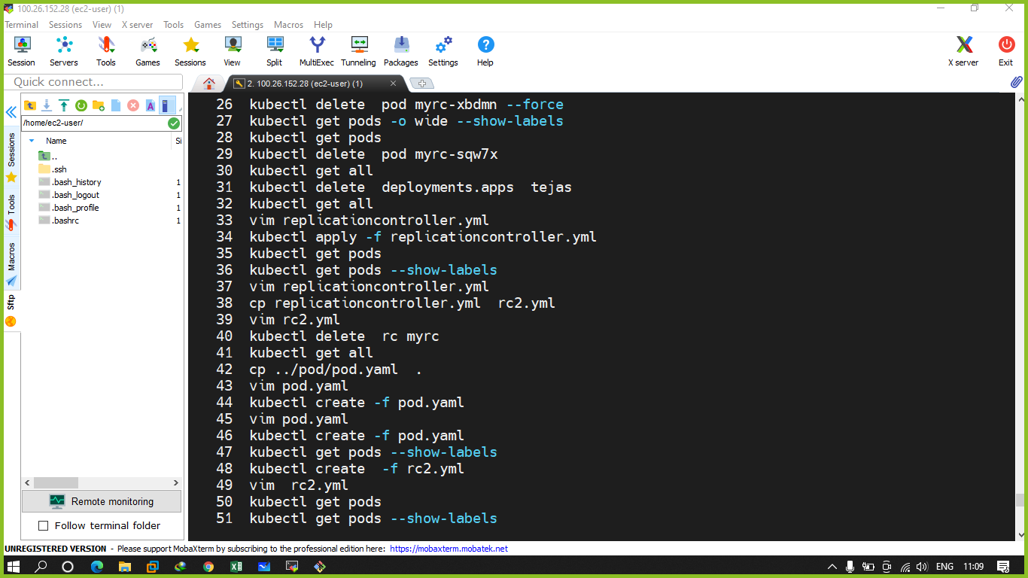

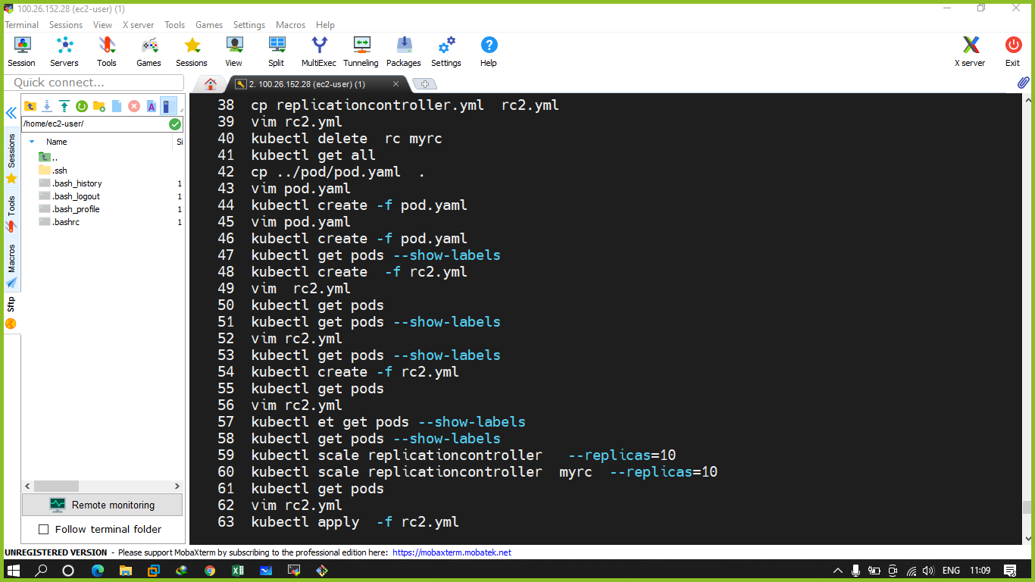

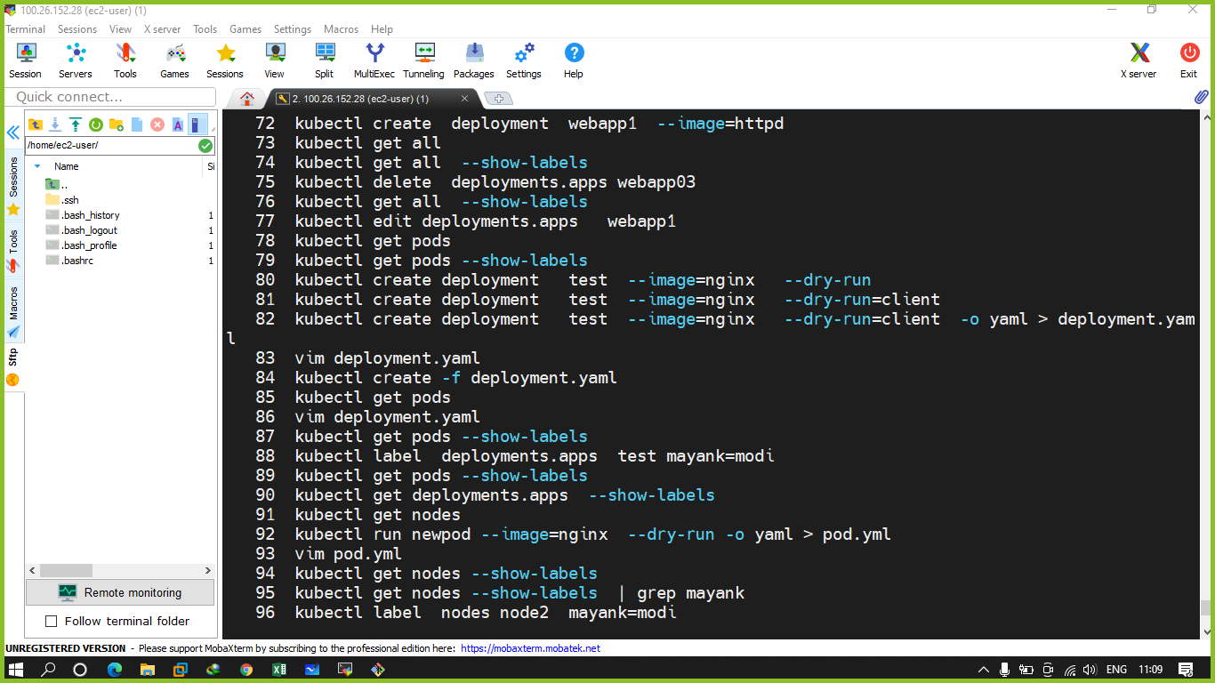

Q.1 create a deployment using image mdhack/myserver and it should be running 3 replicas by using imperative way in ur own namespace

Q.2 create a deployment yaml name of deployment should be app2 and image usedis nginx and while creating it using yaml it should have 10 replicas in ur namespace only

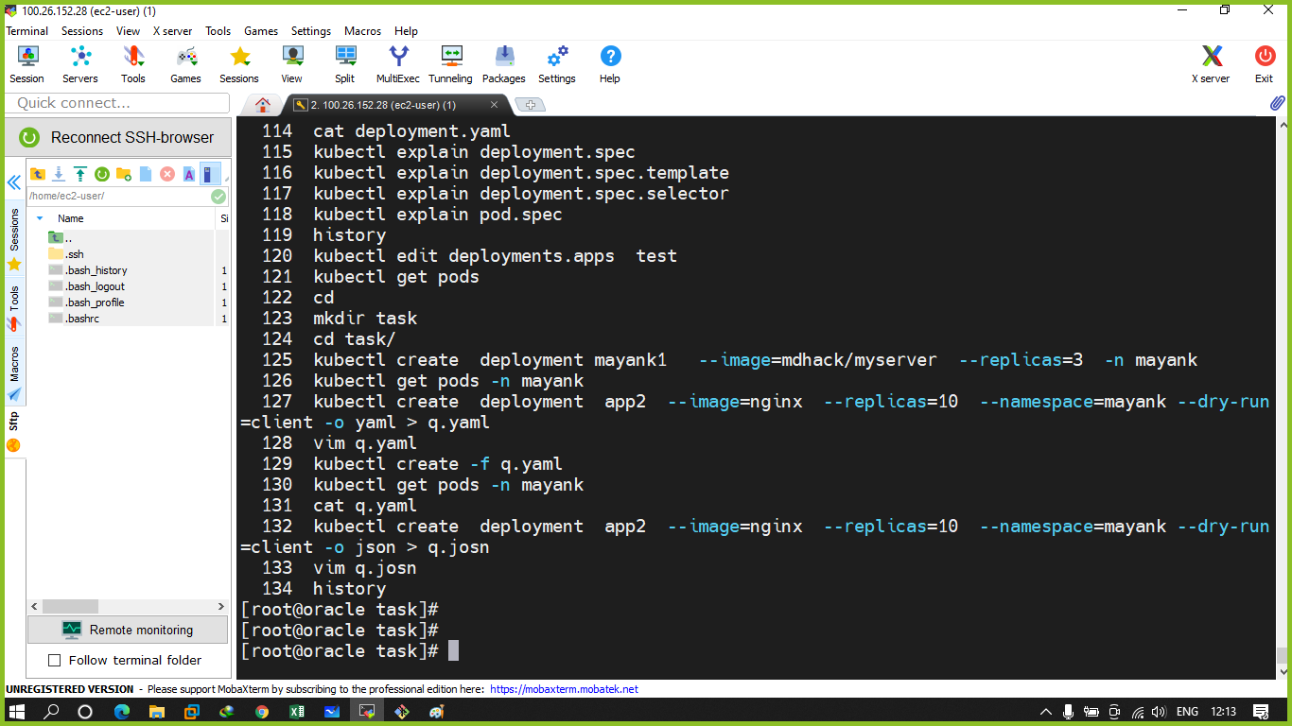

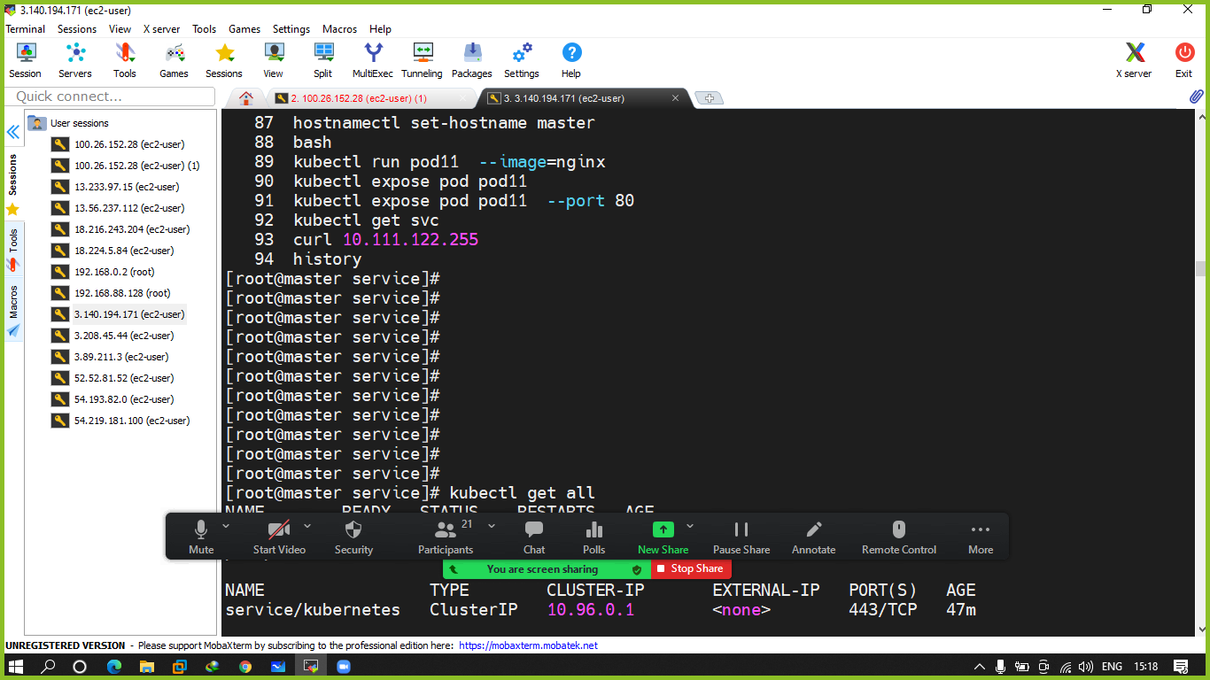

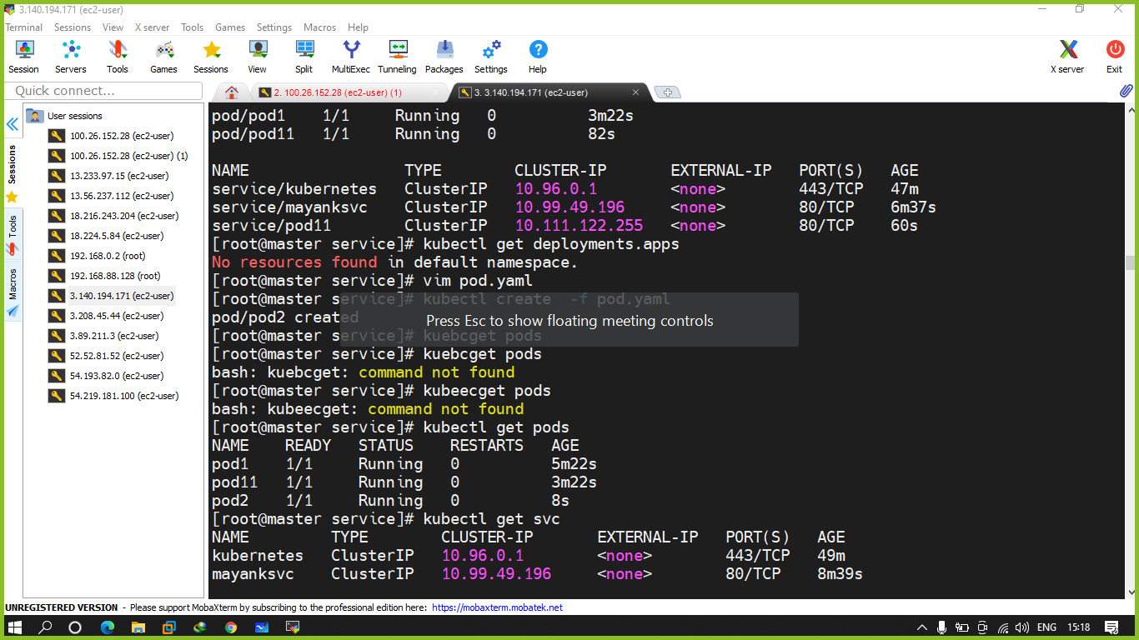

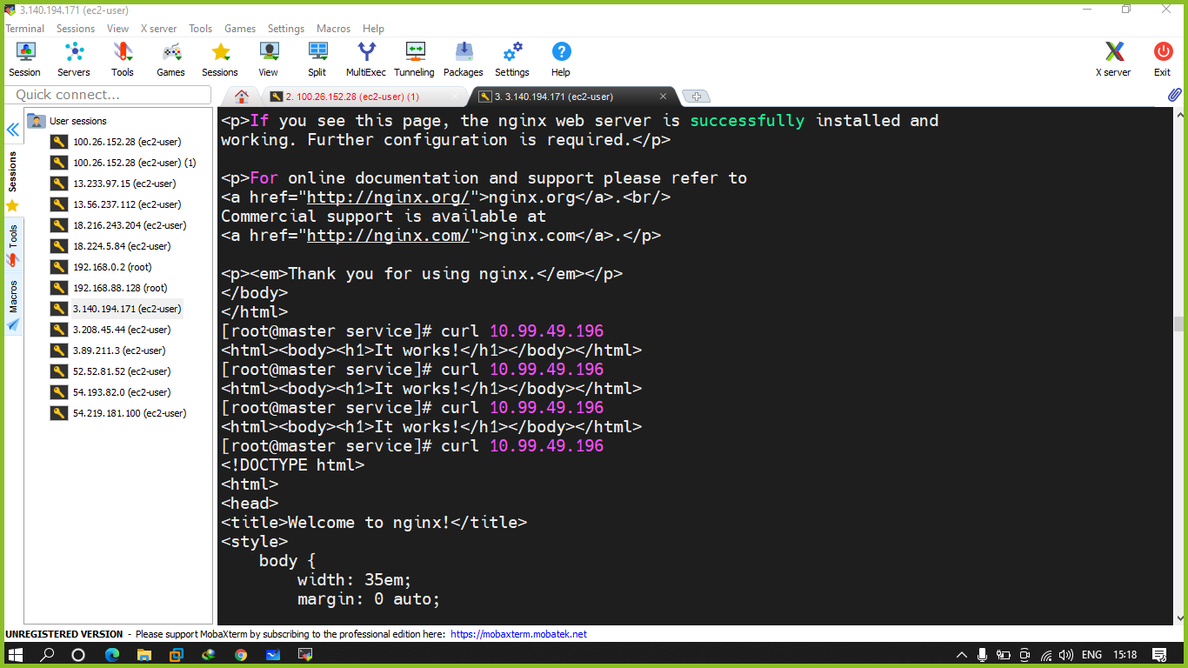

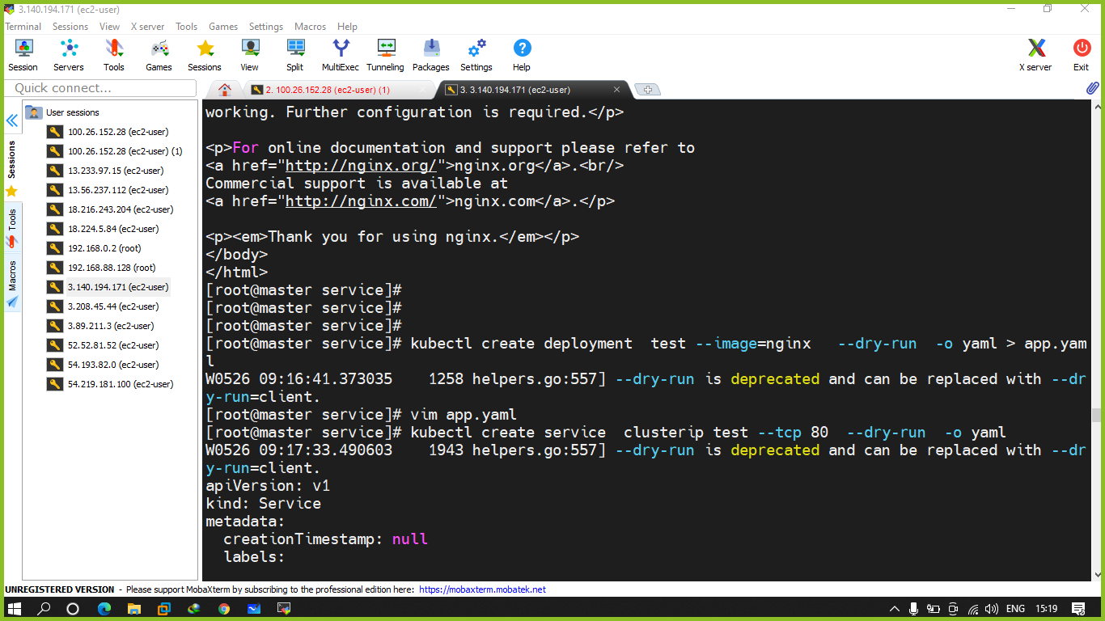

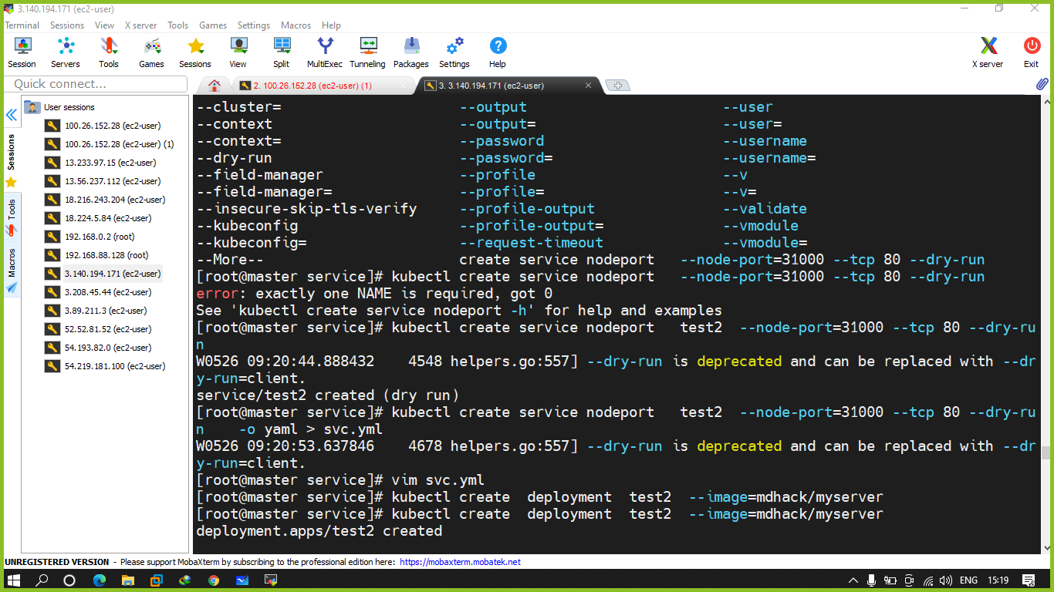

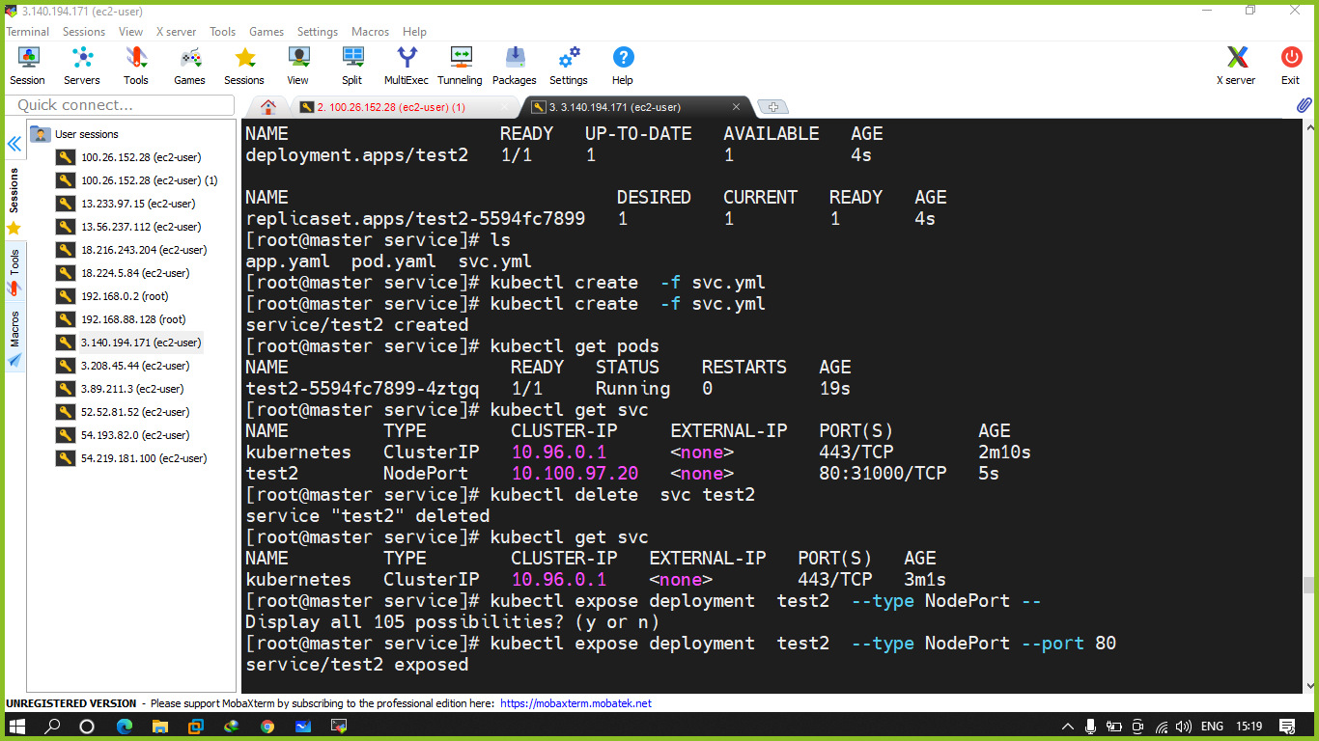

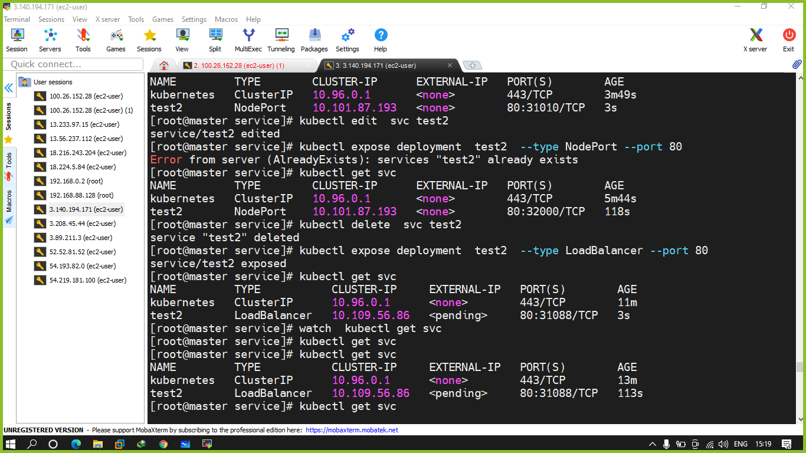

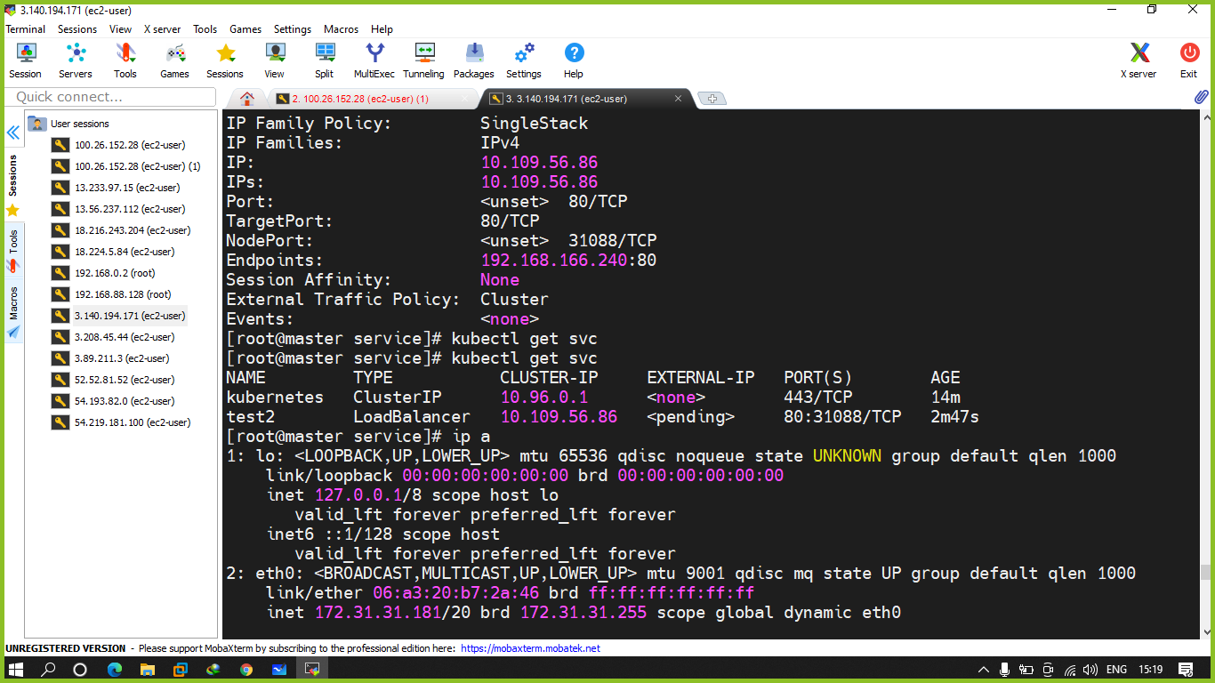

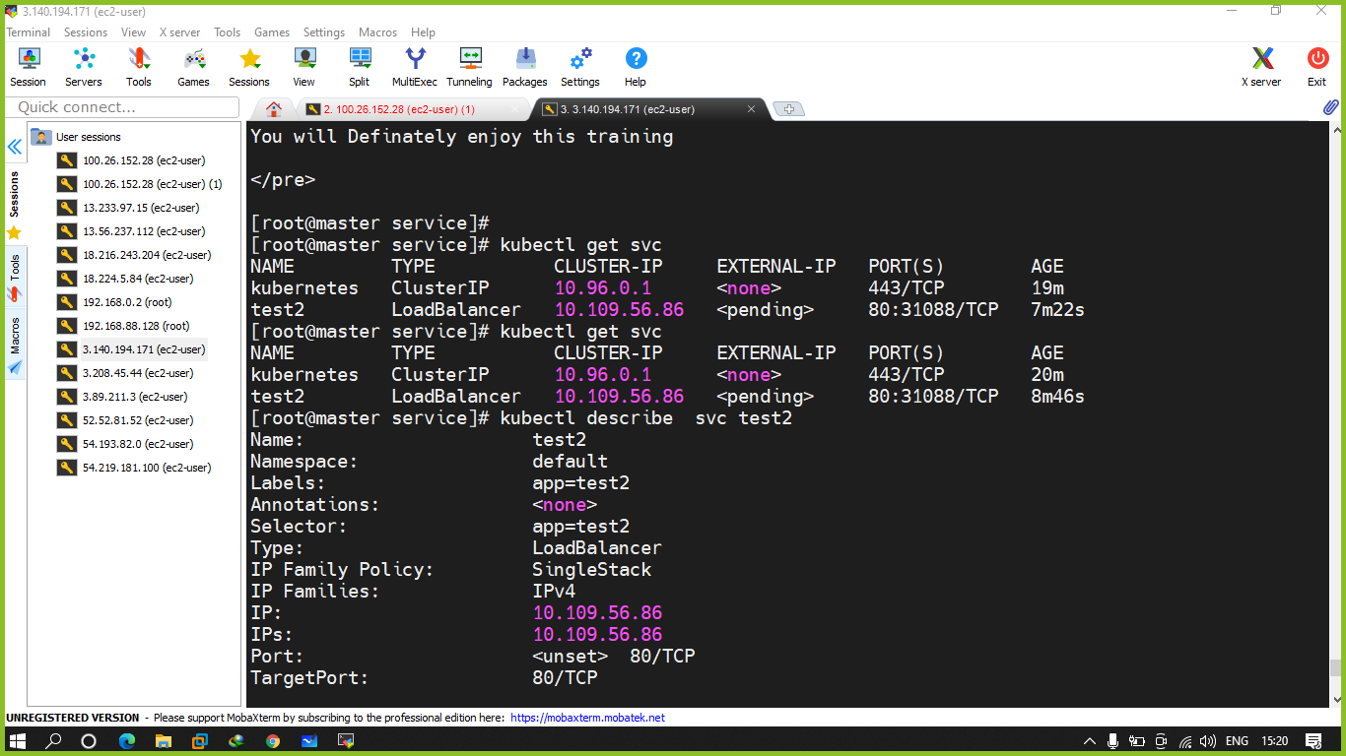

Q.1 first you need top delete everything from your particular namespace

Q.2 create a deployment test1 using mdhack/myapache image and expose it into cluster ip

Q.3 create deploymen t test2 using mdhack/myserver image and expose it with nodeport ip

Q.3 create a yaml test3 th at will create a deployment plus service as well with nodeport

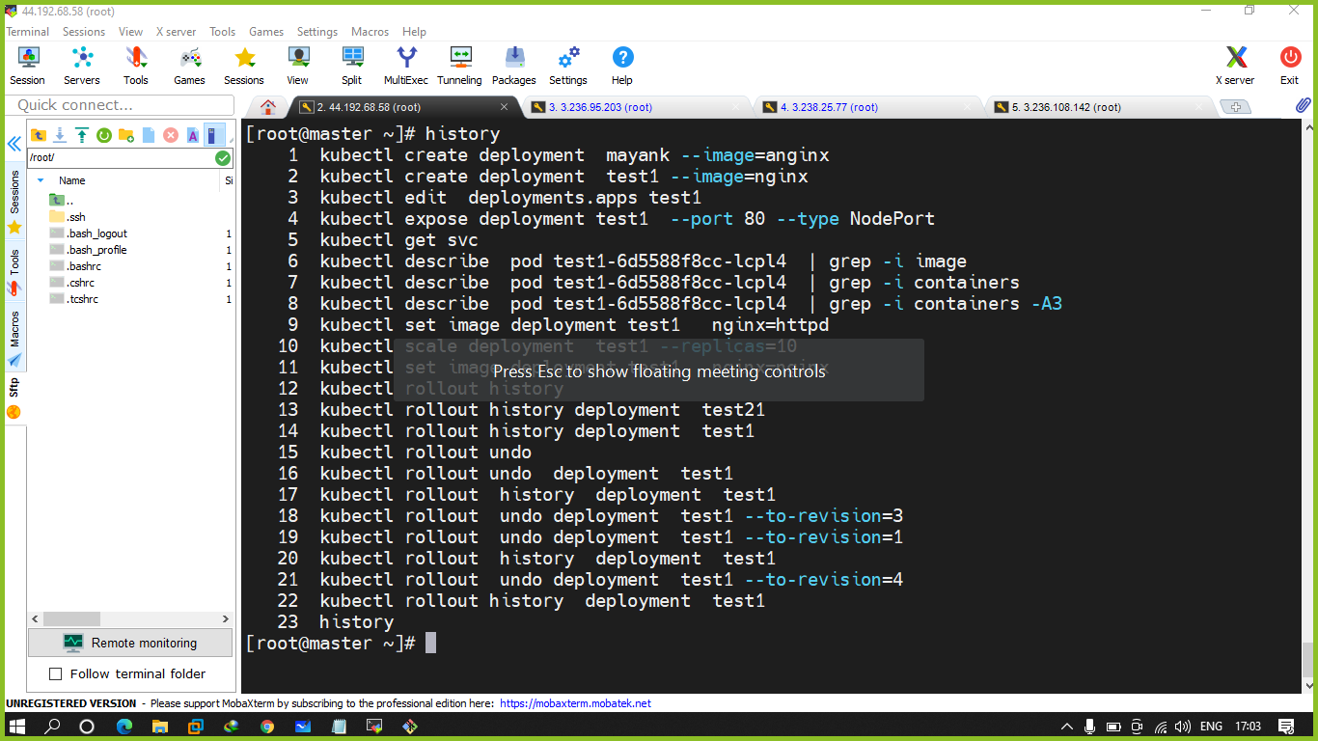

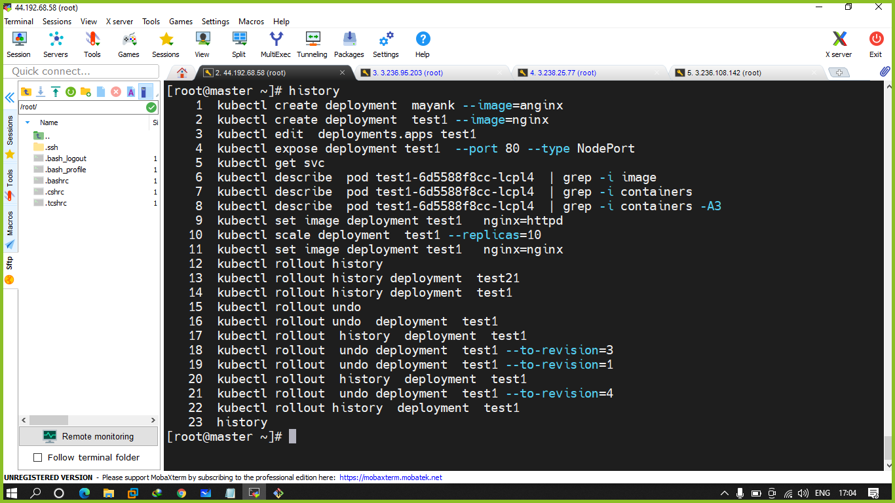

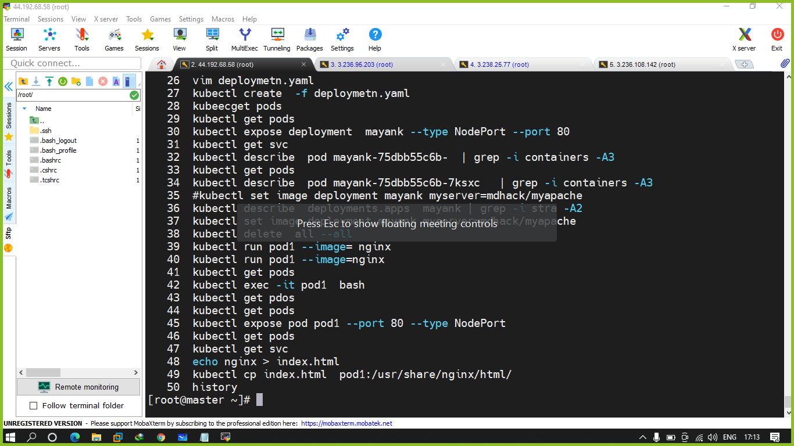

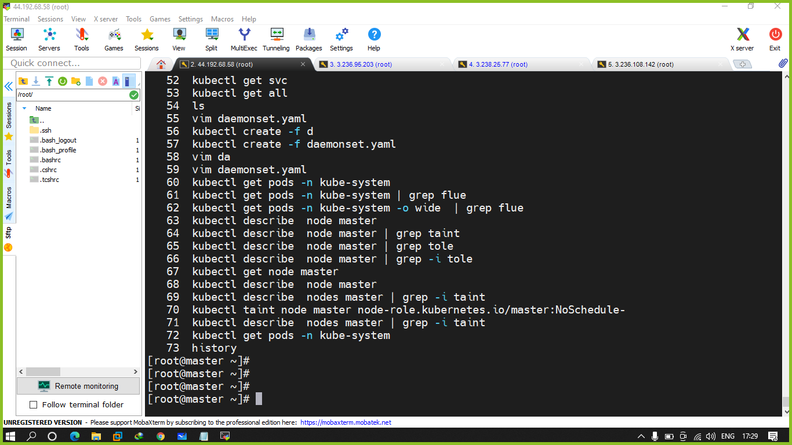

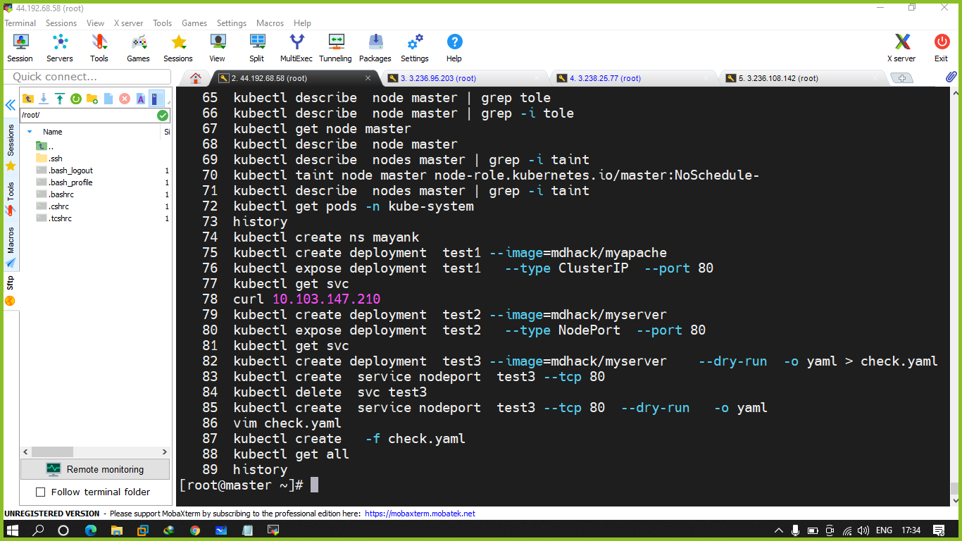

Q create a deployment and expose it with replicas 10 nodeport - strategy should be roilling update --

Verify it by changing the images

Q.2 Recreate strategy